INT404 – Artificial Intelligence

Artificial Intelligence in Sports

School of Computer Science & Engineering

LOVELY PROFESSIONAL UNIVERSITY



SUBMITED BY:-

|  |  |  |
| --- | --- | --- |
| NAME | REGISTRATION NUMBER | ROLL NUMBER |
| Priyanshu Mahajan | 12111571 | 57 |
| Sachin Pachlore | 12110788 | 09 |
| Ritwik Banerjee | 11900866 | 33 |
|  | | |

**Abstract:**

Artificial Intelligence (AI) has become an increasingly popular tool in the sports industry, providing coaches and athletes with personalized insights and recommendations to improve athlete performance and prevent injuries. With the help of AI-powered technologies such as machine learning, computer vision, and natural language processing, large amounts of data can be analyzed quickly and accurately to provide valuable insights into an athlete's performance during practice and games. Coaches can use this information to make informed decisions about an athlete's training regimen and adjust it accordingly to optimize their performance.

AI is also being used to enhance the fan experience by providing real-time statistics, personalized content, and virtual reality experiences. AI can analyse a fan's preferences and past behaviour to provide customized content and experiences, such as personalized highlight reels or virtual meet-and-greets with their favourite athletes. However, the use of AI in sports also raises concerns about data privacy and ethical considerations. It is important to ensure that AI is used in a responsible and transparent manner, with proper oversight. AI is changing the way we approach and interact with sports, and its potential benefits will continue to shape the industry in the future.

Artificial Intelligent technology has been evolving in the last few years, and it is

evident that it is enhancing many sectors. In this case, AI has been of great importance in the sports industry. It has played a significant role in ensuring that the sector evolves from tradition to more modern ways. Also, the businesses associated with sports are growing fast due to high awareness created through this technology. Again, the future will be more confident because of the changes in innovation. Therefore, it is recommendable for sports businesses to stay updated.

Corresponding Author – Priyanshu Mahajan, Sachin Pachlore, and Ritwik Banerjee

# **1. Introduction:**

**AI and its growth**

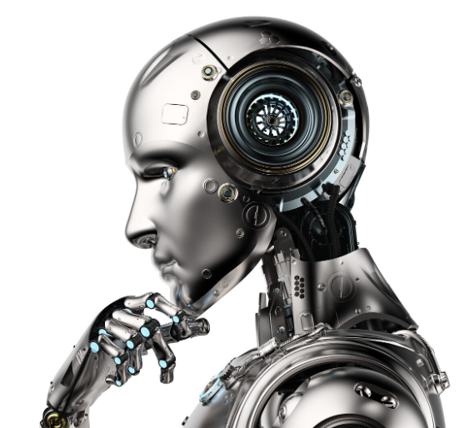Artificial Intelligence (AI) is a rapidly growing field of computer science that focuses on developing machines and algorithms that can perform tasks that would typically require human intelligence to complete. AI has experienced significant growth over the last few years, and its applications can be seen in various domains, including healthcare, finance, transportation, and education.

Some of the factors that have contributed to the growth of AI are:

1. Data availability: With the rise of digitalization, an enormous amount of data is being generated daily. AI algorithms require large amounts of data to learn and make accurate predictions, and the availability of data has fueled the development of sophisticated AI models.
2. Computing power: The development of high-performance computing systems and graphics processing units (GPUs) has enabled AI researchers to train complex machine learning models in a relatively short time.
3. Advancements in machine learning: The development of advanced machine learning algorithms, such as deep learning, has enabled the development of sophisticated AI models that can perform tasks such as speech recognition, image classification, and natural language processing.
4. Investment in AI research: Many organizations and governments worldwide have invested heavily in AI research, leading to the development of novel AI applications and technologies.
5. Cloud computing: Cloud computing services have made it easier and more affordable to access the computing resources required to build and deploy AI applications.

As AI continues to grow, it has the potential to transform various aspects of our lives, from healthcare to transportation and education. However, it also poses significant ethical and societal challenges, such as the potential displacement of human labor, bias, and fairness concerns, and the impact of AI on privacy and security.

AI works in four basic ways, providing:

Automated intelligence

Assisted intelligence

Augmented intelligence

Autonomous intelligence

**1.1 AI Technology Framework for the Sports Industry:**

The following diagram depicts where AI technology can be used within the sporting landscape:

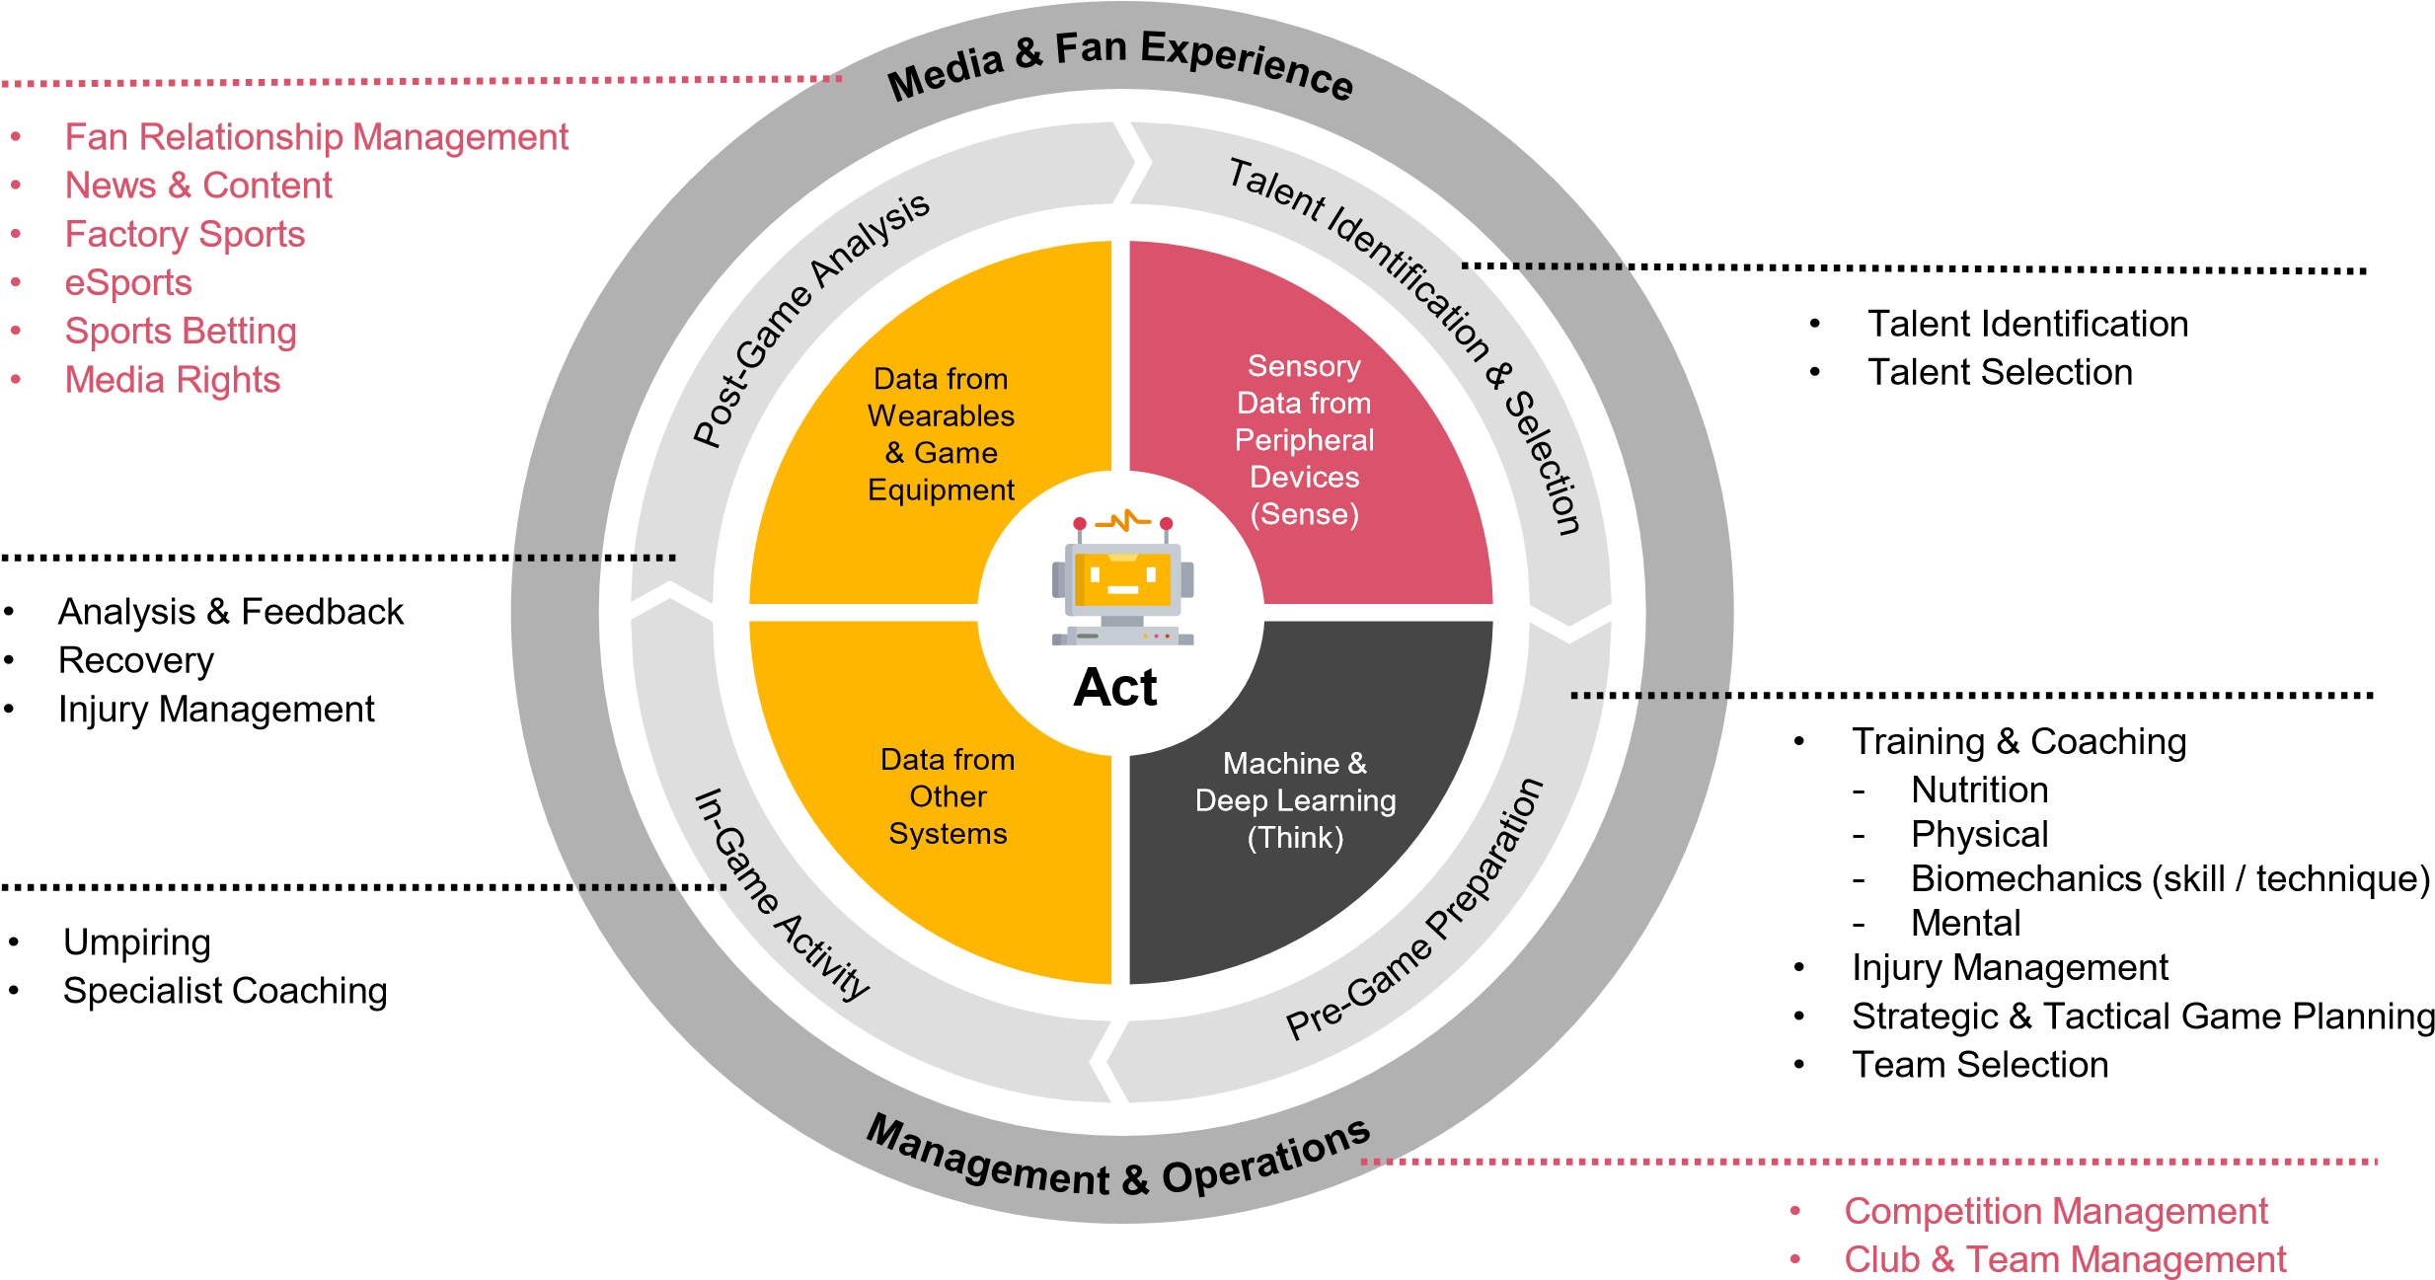

**2. How AI is Being Used in Different Sports:**

* **In Cricket** — AI is used in Cricket to improve the **strategy of the game**. Machine Learning can be used in predicting match results accurately. Thanks to the power of AI, the analysis has now reached an all-time high. Currently, AI is being used in the Umpire Decision Review System (UDRS), Duckworth Lewis, and analyzing the result of run-outs. AI can also be used to develop indoor stadiums or closed stadiums which can ensure that the game continues even in bad weather conditions.

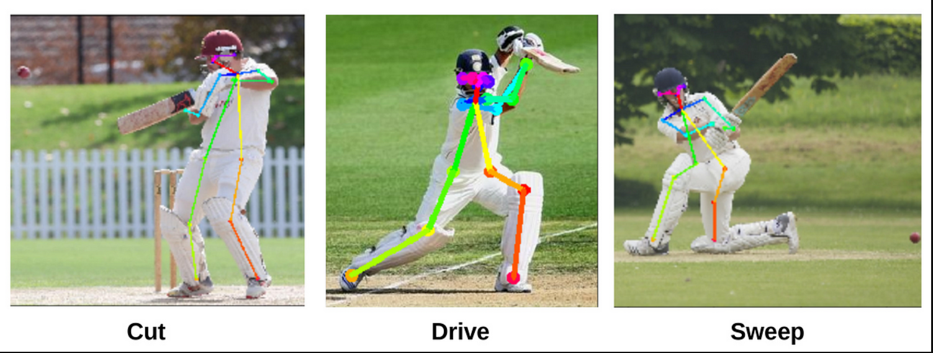

* **In Baseball** — One of the key areas where AI has managed to make a difference in the sport includes**scouting new players**. AI collects information about players, such as their average speed and the angle at which they hit their bat or the speed with which they can throw it in the out. This helps in creating insights for recruiters. It also makes use of VR, i.e. Virtual Reality, a simulation tool that allows batters to practice, and hitters to master throws by specific pitchers!
* **In Football** — It is no secret that insights procured form AI-powered algorithms can add more value to soccer. Technologies like Goal Line Technology (GLT), Video Assistant Referee (VAR) have improved the game’s efficiency by providing additional support to referees to make the right decisions during the game. Furthermore, **[Olocip](https://www.olocip.com/" \t "_blank)**, a Madrid-based company uses machine learning algorithms to predict the success or failure on the field for the next 15 minutes as the game is being played.

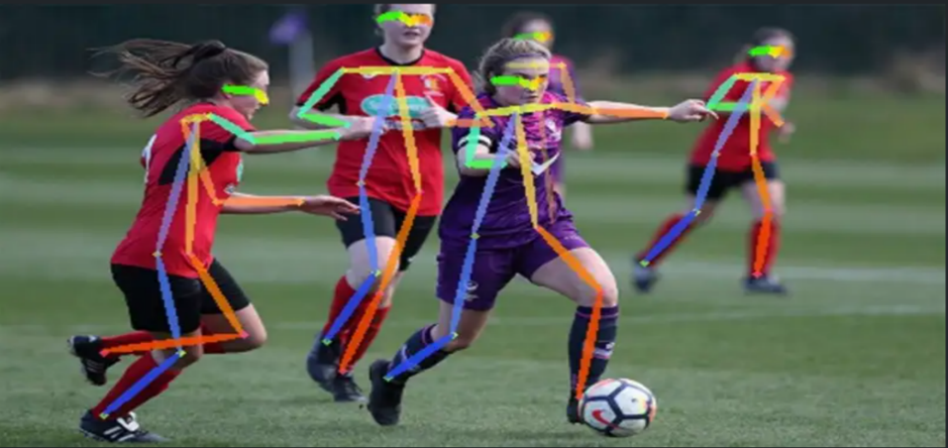

* **In Tennis** — AI has brought Wimbledon to Life; thanks to IBM. It’s groundbreaking Watson AI technology possesses the ability to understand, learn, and interact. It permits tennis fans to see the game from close quarters, thus gaining valuable insights and improving their viewing experience. [**IBM Watson**](https://www.ibm.com/watson) has been taught to recognize the best moments in a match. It does it all: from listening to the noise of the crowd and sensing their reactions to noticing the body language of the audience. It uses all these elements to generate video highlights which can then be shared on social media platforms.
* **In Basketball** — NBA teams have switched their attention to AI and machine learning too. Consider the example of **[HomeCourt](https://www.homecourt.ai/" \t "_blank)**; a computer vision and AI-based app that can help the players improve basketball shooting. The app detects the person, the basket, and the three-point line and finds out if the ball is a make or a miss. It also provides other shooting stats like launch angle, vertical jump, reaction time, and leg angle.

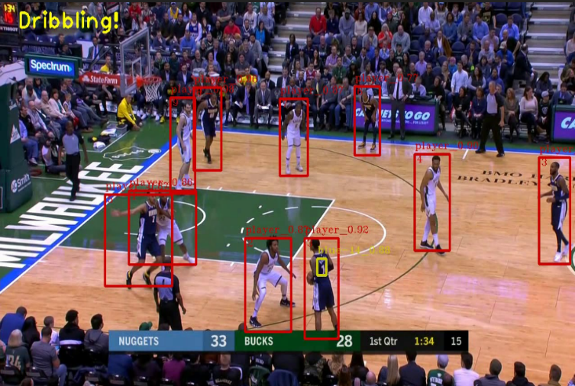

**3. Applications of AI in Sports:**

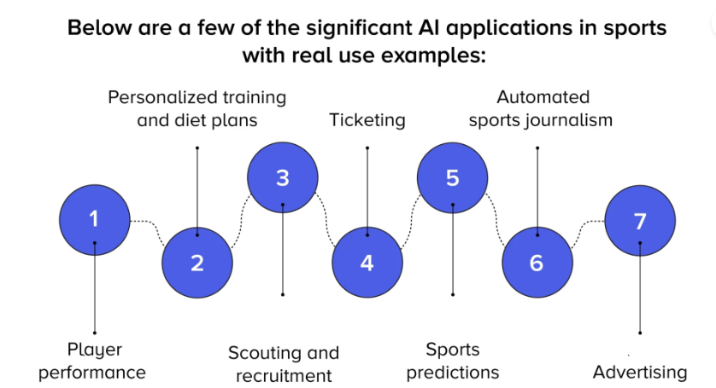

**3.1 Player Performance:** Artificial intelligence (AI) is playing an increasingly important role in analyzing player performance in sports. By analyzing data from wearable devices, video footage, and other sources, AI can provide insights into an athlete's strengths and weaknesses, allowing coaches and teams to develop personalized training programs and strategies.

One application of AI in player performance analysis is through the use of computer vision. By analyzing video footage of games, AI can identify key performance indicators, such as speed, accuracy, and movement patterns, which can be used to assess a player's overall performance. This information can be used to develop personalized training programs and make more informed decisions about player selection.

Another application of AI in player performance analysis is through the use of machine learning algorithms. These algorithms can analyze player statistics, such as shooting accuracy or tackling efficiency, to identify patterns and trends over time. By continuously learning from new data, machine learning algorithms can improve their accuracy over time and provide insights that were previously impossible to obtain.

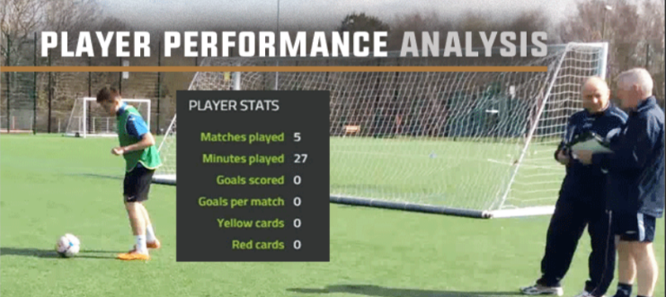

**3.2 Personalized training and diet plan:** AI is on a track to winning in sports; this is concluded by how AI has taken personal training to the next level. An AI diet plan uses machine learning to customize different meal plans for different players based on their needs and schedule. And that’s just the beginning.

Not to forget about the featured [AI-based fitness apps](https://appinventiv.com/blog/15-features-that-could-make-your-fitness-app-popular-like-fitbit/) that have flooded the market. These tools and techniques can now train algorithms to detect human poses in real-time.

One popular example is [women’s fitness app development](https://appinventiv.com/blog/women-health-tracking-app-development/), where keypoint skeleton models are used to identify human joints for online yoga and pilates.



**3.3 Scouting and Recruitment:** Scouting and recruitment in sports have been transformed by the use of artificial intelligence (AI). AI can analyze vast amounts of data and provide insights into the performance of players, allowing teams to make more informed decisions about who to recruit. One application of AI in scouting and recruitment is through the use of computer vision. By analyzing video footage of players, AI can identify key performance indicators, such as speed, accuracy, and movement patterns, which can be used to assess a player's potential. This can save scouts and coaches a significant amount of time and resources by automating the video analysis process.

Another application of AI in scouting and recruitment is through the use of machine learning algorithms. These algorithms can analyze player statistics, such as shooting accuracy or tackling efficiency, to identify players with high potential. By continuously learning from new data, machine learning algorithms can improve their accuracy over time.

AI can also be used to identify players who may be overlooked by traditional scouting methods. By analyzing data from lower-tier leagues or less-popular sports, AI can identify players who may have been overlooked by scouts and coaches.

**3.4 Ticketing:** Ticketing in sports has been revolutionized by the use of artificial intelligence (AI) in recent years. AI can be used to improve the entire ticketing process, from purchase to entry into the venue.

One way AI is used in ticketing is through dynamic pricing. By analyzing data such as weather, team performance, and demand, AI can adjust ticket prices in real-time to optimize revenue for the team and ensure that the seats are filled. This also allows for more accessible ticket prices for fans during lower demand times.

Another application of AI in ticketing is through facial recognition technology. By using facial recognition, fans can quickly and easily enter the venue without the need for physical tickets or lengthy security checks. This not only enhances the fan experience but also improves venue security.

AI can also be used to personalize the ticket buying experience. By analyzing past purchases and preferences, AI can recommend seat locations and special promotions tailored to each fan's individual interests.

**3.5 Sports Prediction:** Sports prediction is an area where artificial intelligence (AI) has shown great potential in recent years. By analyzing vast amounts of data, AI can make more accurate predictions about the outcomes of sports events, which can be used for sports betting, fantasy sports, and other purposes.

One application of AI in sports prediction is through the use of machine learning algorithms. These algorithms can analyze past performance data, such as player statistics, team rankings, and historical matchups, to make predictions about future events. By continuously learning and updating their predictions, machine learning algorithms can improve their accuracy over time.

Another application of AI in sports prediction is through natural language processing (NLP) and sentiment analysis. By analyzing social media and news articles, AI can determine the sentiment of fans and experts towards a particular team or player, and incorporate this information into its predictions.

AI can also be used to predict the likelihood of player injuries and their impact on a team's performance. By analyzing player workload, injury history, and other factors, AI can help teams make better decisions about player rotation and recovery.

**3.6 Automated Sports Journalism:** Automated sports journalism is an emerging application of AI, where algorithms are used to generate news articles, match reports, and other content related to sports events. AI can process large amounts of data in real-time and produce high-quality content that can be published almost immediately. This has the potential to revolutionize the way sports news is delivered to fans.

One application of AI in automated sports journalism is the use of natural language generation (NLG) software to generate news articles. NLG software uses algorithms to analyze data such as game statistics, player performance, and historical trends to generate text that reads like it was written by a human. This type of software can produce large volumes of content quickly and accurately, allowing news outlets to cover a wider range of sports events and reach a larger audience.

Another application of AI in automated sports journalism is the use of computer vision to analyze video footage of sports events. Computer vision algorithms can identify players, track their movements, and even detect subtle changes in body language and facial expressions. This information can be used to generate insights and analysis that can help fans understand the game better.



**3.7 Advertising:** Artificial intelligence (AI) is increasingly being used to enhance advertising in sports by improving targeting, personalization, and engagement. By analyzing data from various sources, including social media, TV viewership, and fan demographics, AI can help advertisers develop more effective campaigns and reach their target audiences more efficiently.

One application of AI in sports advertising is through the use of predictive analytics. By analyzing data on consumer behavior and preferences, AI can predict which ads are likely to resonate with which viewers, enabling advertisers to deliver more relevant and personalized content to their audiences. This can lead to higher engagement rates and better returns on investment for advertisers.

Another application of AI in sports advertising is through the use of chatbots and virtual assistants. These tools can interact with fans and provide personalized recommendations and information about products and services. By engaging with fans in real-time and delivering relevant content, AI-powered chatbots can improve the overall fan experience and drive customer loyalty.

## 

## **4. AI Statistics in Sports:**

* As per recent studies, the global artificial intelligence sports market was worth[$1.8 billion](https://www.marketwatch.com/press-release/artificial-intelligence-in-sports-market-2022-key-players-regions-company-profile-growth-opportunity-and-challenges-by-2030-2022-03-07) in 2021. It is forecasted to reach $19.9 billion by the year 2030.
* This would make a total Compound Annual Growth Rate (CAGR) of 30.4% during the forecast period from 2022 to 2030.

Some of the factors influencing the market growth are :

* Increase in demand for player monitoring and tracking
* The rise in demand for real-time data analytics
* Growing demand for AI for forecasts and sports predictions
* Demand for virtual assistants and Chatbots to interact with fans and sports enthusiasts.

Another study suggests that mobile applications such as HomeCourt, ESPN, AI SmartCoach, etc., are used to assess players’ skills, giving them a good medium to improve.

The above data proves how AI influences the sports industry to be data and information-rich. Not just popular sports but certain Sports enterprises rely entirely on AI and machine learning to drive their business.

## **5. AI in Sports real-world examples:**

**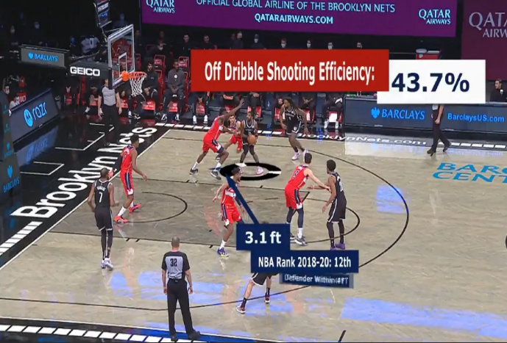5.1** [**NBA court powered by Microsoft Azure**](https://nbacourtoptix.nba.com/en)  
It is a software that uses AI and Machine Learning to transform analytics. The NBA processes a huge amount of data that is simply beyond the power of a human. That is why they have developed a special platform based on Microsoft Azure.  
The main metrics ball screens, passing, defensive scores, shooting.

**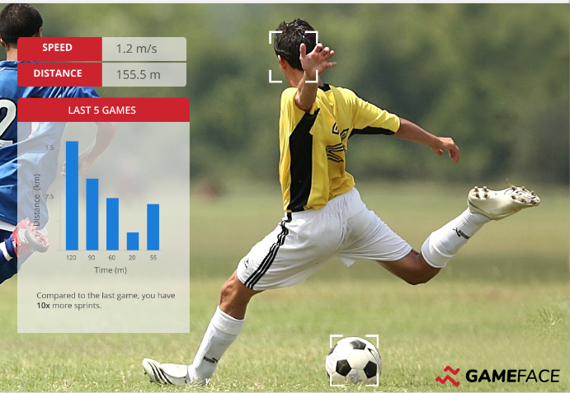5.2** [**Gameface AI**](https://gameface.ai/)  
This application allows you to get match insights in any sport through video analysis. The main events are a goal, passing the ball, shooting on goal, passing schemes.

**5.3** [**Kemtai**](https://kemtai.com/)  
A platform has many use cases - from sports to physical therapy. Computer Vision models are trained to detect 44 points on the body, even the most complex movements can be analyzed with ease.

**6. IMPLEMENTATION**

**6.1 Human Pose Estimation:**

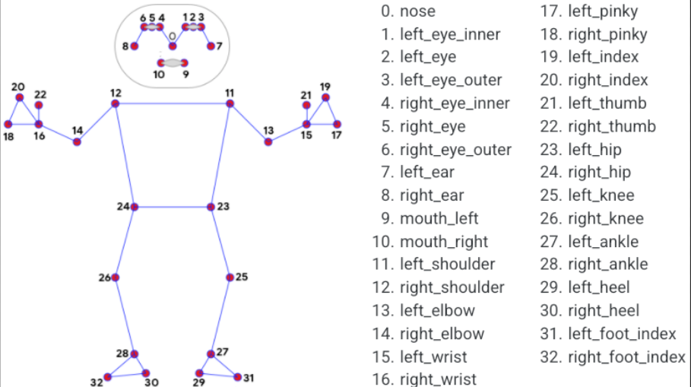In this project we have implemented Human Pose Estimation in python using opencv and mediapipe. With the help of Human Pose estimation we can detect the movement of different body parts such as knee, hip , shoulder, elbow, etc of the sportsperson. In our project we have imported mediapipe which includes 33 pose landmarks. All these landmarks have a specific number associaciated with them and with the help of these we can track the particular body part which provides a lot of benefits to the trainer and the athlete in order to perform a particular action in sports in correct manner.

Human pose estimation in sports is a computer vision technique that involves detecting and tracking the movements of human body joints and estimating their positions in real-time. In sports, it is commonly used to analyze an athlete's performance, identify incorrect postures, and provide feedback to improve their technique.

The process of human pose estimation in sports involves the following steps:

* Capture input data: This can be done using a camera or sensors that track the athlete's movements.
* Pre-processing: The input data is then pre-processed to remove noise, correct for camera distortion, and normalize the data for further processing.
* Feature extraction: In this step, a set of distinctive features is extracted from the input data, such as key points or landmarks of the human body.
* Pose estimation: The extracted features are then used to estimate the athlete's pose or joint positions. This can be done using deep learning-based techniques, such as Convolutional Neural Networks (CNNs), Recurrent Neural Networks (RNNs), or Graph Neural Networks (GNNs).
* Post-processing: Once the pose estimation is completed, the results are post-processed to smooth the output and correct any errors or inconsistencies.
* Analysis: The final step involves analyzing the results to provide feedback to the athlete or coach. This may include identifying incorrect postures, tracking the athlete's progress over time, and providing recommendations for improvement.

There are several challenges in human pose estimation in sports, such as occlusion, noise, and changes in lighting conditions. To overcome these challenges, researchers are exploring new techniques such as multi-view human pose estimation, multi-modal data fusion, and data augmentation.

Overall, human pose estimation in sports is an exciting field that has the potential to revolutionize athlete training and improve performance. It requires a combination of computer vision, machine learning, and sports science expertise, and is an active area of research with many open challenges and opportunities for innovation.

**6.2 Applications of Human Pose Estimation:**

Human Pose Estimation has many applications in the sports industry, including the following:

* Performance analysis: Human pose estimation can be used to track the movements of athletes during a game or training session. This information can be used to analyze their performance, identify areas for improvement, and provide feedback.
* Injury prevention: Human pose estimation can also be used to monitor athletes for signs of fatigue or injury. By tracking changes in their posture or movement patterns, coaches and trainers can identify potential issues early and take steps to prevent injuries.
* Virtual coaching: Human pose estimation can be used to create virtual coaching systems that provide real-time feedback to athletes. By analyzing their movements and comparing them to ideal or correct form, these systems can help athletes improve their technique and avoid injury.
* Broadcasting: Human pose estimation can also be used in sports broadcasting to enhance the viewing experience. By tracking the movements of athletes, broadcasters can create virtual replays and visualizations that provide viewers with a better understanding of the action.

Overall, human pose estimation has the potential to revolutionize the way sports are played, analyzed, and broadcasted. By providing coaches, trainers, and broadcasters with detailed information about athletes' movements, it can help improve performance, prevent injuries, and enhance the viewing experience for fans.

### **7. Future of AI in sports:**

One of the potential future developments is the use of virtual and augmented reality technology. This was highlighted in the [Mastercard Sport Economy Index 2023](https://www.mastercard.com/news/europe/en/newsroom/press-releases/en/2023/european-passion-for-sport-burns-bright-as-gyms-stadiums-and-technology-thrive/), with over a quarter of European sports fans having already experienced sport via VR. According to the report “VR also looks set to form a key part of the stadium of the future, with 21% of fans hoping to experience immersive technology that demonstrates what it feels like to be an athlete on matchday.” The technology could provide fans with an even more immersive and engaging experience. Fans could use VR headsets to watch live games from a player's perspective or use AR to overlay stats and other information on top of the live action. Coaches and players could use this for training purposes, adding a further layer to what is already happening.

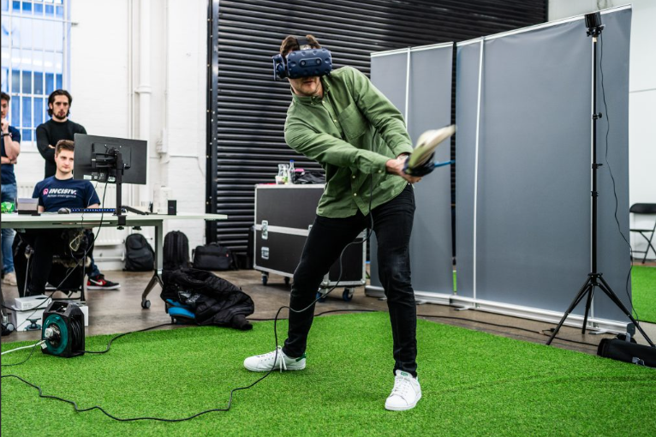

Adding to that are the new ways to interpret performance. The continued advancement of machine learning technology will allow teams to gain insights on larger data sets. They will be able to make more accurate predictions about a player's performance, leading to more effective training programs and better decision-making.

As technology continues to improve, the use of wearables and other sensors is likely to become more widespread. More data will be provided on a player's performance which can improve training and make informed decisions about player management.

There is also a role for AI in sports betting. Providing more accurate predictions about the outcome of games and other events could lead to more successful outcomes for individuals and sports betting companies.

Finally, further collaboration between humans and AI can bring new and innovative ways to improve all areas of sport. This is because it has the potential to bring together the best of both worlds. AI can provide teams with valuable insights and predictions; humans can provide the context, creativity and decision-making skills.

**8. Challenges Involved in AI in Sports:**

Artificial intelligence (AI) has the potential to revolutionize sports by enabling data-driven decision-making and creating new training and performance optimization opportunities. However, the implementation of AI in sports also poses significant challenges. Here are some of the key challenges involved in AI in sports

* Data collection: AI models rely on high-quality data to provide accurate predictions and insights. In sports, collecting relevant data can be challenging due to the complexity of the game and the variability of the data. Data collection requires an appropriate infrastructure to collect, store, and manage the data.
* Data privacy: With the increasing use of wearable technology and other sensors, there is a risk of sensitive information being compromised. Ensuring the privacy of athletes' data is crucial, and any breach could have serious consequences.
* Bias: AI models are only as good as the data they are trained on. If the data used to train an AI model is biased, the model will also be biased. This can lead to inaccurate predictions or unfair treatment of certain athletes. For example, if the data used to train an AI model only includes male athletes, the model may not be able to accurately predict the performance of female athletes.
* Interpretability: AI models can be complex, making it difficult to understand how they arrive at their predictions. This can make it challenging for coaches and athletes to trust and use the predictions effectively. It is important to ensure that the AI models are transparent and interpretable.
* Implementation costs: The implementation of AI technology in sports can be expensive, making it challenging for smaller teams or organizations to adopt it. The costs associated with data collection, infrastructure, and software can be significant, and many organizations may not have the necessary resources to invest in AI technology.
* Resistance to change: There may be resistance to the adoption of AI technology in sports due to a fear of job losses or a belief that human intuition and experience are irreplaceable. It is important to educate coaches, athletes, and other stakeholders about the potential benefits of AI in sports and address any concerns they may have.

**9. Conclusion:**

In conclusion, AI has become an increasingly important tool in the world of sports. Its ability to analyze vast amounts of data, provide personalized insights, and enhance the fan experience is transforming the industry.

AI is being used in a variety of ways in sports, including player performance analysis, injury prevention, scouting and recruitment, and advertising. By leveraging machine learning algorithms, computer vision, and natural language processing, AI is providing coaches, teams, and fans with valuable insights that were previously impossible to obtain.

One of the most significant benefits of AI in sports is its ability to improve performance and prevent injuries. By analyzing data from wearable devices and other sources, AI can identify patterns and trends that may not be visible to the naked eye. This information can be used to develop personalized training programs, reduce the risk of injuries, and improve overall performance.

Furthermore, AI is improving the fan experience by providing personalized recommendations, engaging virtual assistants, and customized merchandise recommendations. By delivering more relevant content to fans, AI is enhancing engagement and driving customer loyalty.

While there are still some challenges to overcome, such as data privacy and ethical concerns, the potential benefits of AI in sports are enormous. As the technology continues to evolve and improve, it will undoubtedly play an even more significant role in the future of sports.

**References:**

1. Buldú, J. M., Busquets, J., Del Pozo, F., & Fornes, J. (2019). Artificial intelligence in sports: a systematic review. Frontiers in Psychology, 10, 456. doi: 10.3389/fpsyg.2019.00456.

2. Haugen, T., Seiler, S., & Sandbakk, Ø. (2018). Systematic analysis of lactate threshold and VO2max from a single incremental exercise test. Sports Medicine, 48(8), 1879-1887. doi: 10.1007/s40279-018-0935-5.

3. Kuznetsov, A., Ryabko, D., Ovchinnikov, A., & Shapovalov, A. (2020). AI in sports: an overview of research problems and approaches. Journal of Artificial Intelligence and Data Mining, 8(2), 151-159. doi: 10.14258/jaidef.2020.8.2.12.

4. Li, X., Wang, G., Li, B., & Li, W. (2019). Research on the application of artificial intelligence technology in sports training. Journal of Physics: Conference Series, 1202, 022026. doi: 10.1088/1742-6596/1202/2/022026.

5. MacMahon, C., & Cadden, P. (2021). Artificial intelligence in sports: a critical review. Journal of Sports Sciences, 39(2), 133-148. doi: 10.1080/02640414.2020.1825011.

6. Papadopoulos, N., & Pavlidis, P. (2019). AI in sports: current and future trends. Frontiers in Robotics and AI, 6, 57. doi: 10.3389/frobt.2019.00057.

7. Ravi, D., Wong, C., Lo, B., & Yang, G. Z. (2017). Rationalizing sports training data through machine learning: a survey. Smart Health, 6-7, 39-57. doi: 10.1016/j.smhl.2017.10.001.

8. Rodriguez-Sanchez, A. I., Antequera-Solís, J., & Rodríguez-Rodríguez, F. J. (2019). Artificial intelligence in sports: a bibliometric analysis. Sustainability, 11(21), 6014. doi: 10.3390/su11216014.